Software is a set of programs, which is designed to perform a well-defined function. A program is a sequence of instructions written to solve a particular problem.

There are two types of software −

- System Software
- Application Software
System Software
The system software is a collection of programs designed to operate, control, and extend the processing capabilities of the computer itself. System software is generally prepared by the computer manufacturers. These software products comprise of programs written in low-level languages, which interact with the hardware at a very basic level. System software serves as the interface between the hardware and the end users.
Some examples of system software are Operating System, Compilers, Interpreter, Assemblers, etc.
Operating systems
which are essential collections of software that manage resources and provides common services for other software that runs "on top" of them. Supervisory programs, boot loaders, shells and window systems are core parts of operating systems. In practice, an operating system comes bundled with additional software (including application software) so that a user can potentially do some work with a computer that only has one operating system.
Device drivers
which operate or control a particular type of device that is attached to a computer. Each device needs at least one corresponding device driver; because a computer typically has at minimum at least one input device and at least one output device, a computer typically needs more than one device driver.
Utilities
which are computer programs designed to assist users in the maintenance and care of their computers.

Application software
which is software that uses the computer system to perform special functions or provide entertainment functions beyond the basic operation of the computer itself. There are many different types of application software, because the range of tasks that can be performed with a modern computer.
Application software products are designed to satisfy a particular need of a particular environment. All software applications prepared in the computer lab can come under the category of Application software.
Application software may consist of a single program, such as Microsoft's notepad for writing and editing a simple text. It may also consist of a collection of programs, often called a software package, which work together to accomplish a task, such as a spreadsheet package. Features of application software are as follows −

Close to the user
Easy to design
More interactive
Slow in speed
Generally written in high-level language
Easy to understand
Easy to manipulate and use
Bigger in size and requires large storage space

Examples of Application software are the following −

Payroll Software
Student Record Software
Inventory Management Software
Income Tax Software
Railways Reservation Software
Microsoft Office Suite Software
Microsoft Word
Microsoft Excel
Microsoft PowerPoint
System software
which is software that directly operates the computer hardware, to provide basic functionality needed by users and other software, and to provide a platform for running application software.[2] System software includes:
Here is a list of some of the most prominent features of a system software −

Close to the system
Fast in speed
Difficult to design
Difficult to understand
Less interactive
Smaller in size
Difficult to manipulate
Generally written in low-level language
Application Software
Application software products are designed to satisfy a particular need of a particular environment. All software applications prepared in the computer lab can come under the category of Application software.

Application software may consist of a single program, such as Microsoft's notepad for writing and editing a simple text. It may also consist of a collection of programs, often called a software package, which work together to accomplish a task, such as a spreadsheet package.

Examples of Application software are the following −

Payroll Software
Student Record Software
Inventory Management Software
Income Tax Software
Railways Reservation Software
Microsoft Office Suite Software
Microsoft Word
Microsoft Excel
Microsoft PowerPoint
Operating system:
An operating system (OS) is a system software responsible for the direct control and management of hardware and basic system operations. In other words an operating system is a interface between user and computer hardware. Which provides interface which is more convenient to use. So operating system is a master control program that runs the computer which is one of the central program. An Operating System (OS) is an interface between computer user and computer hardware. An operating system is software which performs all the basic tasks like file management, memory management, process management, handling input and output, and controlling peripheral devices such as disk drives and printers. An Operating System, or OS, is a software program that enables the computer hardware to communicate and operate with the computer software. Without a computer Operating System, a computer would be useless.
An operating system manages computer hardware including cpu, I/O devices, secondary storage and network equipments. Some popular Operating Systems include Linux, Windows, OS X, VMS, OS/400, AIX, z/OS, etc.

OS
monitor
printer
CD-ROM
mouse
Application programs
CPU
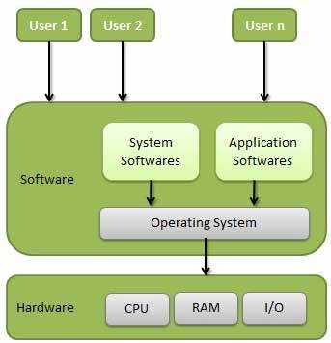
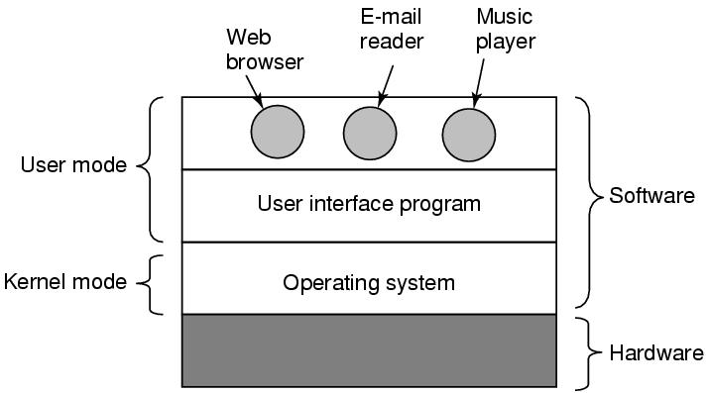

The primary objectives of operating system Are as follows:
1:Making the computer system convenient to use.
Os manages all parts of the system and presents the user with interface which is easier to program and use.so it hides details about hardware.
2:Managing the resources of a computer system:The objectives of an operating system is to manage various resources of the computer system,this involves performing such tasks as keeping track of who is using which resources, granting resources request.
Main function of operating system:
Important functions of an operating System.
- INPUT/OUTPUT management
- Memory Management
- Processor Management
- Device Management
- File Management
- Security
- Control over system performance
- Job accounting
- Error detecting aids
- Coordination between other software and users
INPUT/OUTPUT management: one of the important function of operating system is to manage the input and output of data in a computer system,which means flow of data among computers,terminals and other devices such as printers Application program use operating system to handle input and outputs devices as needed. Operating system has greatest responsibility and power. Which makes sure that different programs and user running at the same time do not interfere with each other.

Memory Management
Memory management refers to management of Primary Memory or Main Memory. Main memory is a large array of words or bytes where each word or byte has its own address.
Main memory provides a fast storage that can be accessed directly by the CPU. For a program to be executed, it must in the main memory. An Operating System does the following activities for memory management −
- Keeps tracks of primary memory, i.e., what part of it are in use by whom, what part are not in use.
- In multiprogramming, the OS decides which process will get memory when and how much.
- Allocates the memory when a process requests it to do so.
- De-allocates the memory when a process no longer needs it or has been terminated.
Processor Management
In multiprogramming environment, the OS decides which process gets the processor when and for how much time. This function is called process scheduling. An Operating System does the following activities for processor management −
- Keeps tracks of processor and status of process. The program responsible for this task is known as traffic controller.
- Allocates the processor (CPU) to a process.
- De-allocates processor when a process is no longer required.
Device Management
An Operating System manages device communication via their respective drivers. It does the following activities for device management −
- Keeps tracks of all devices. Program responsible for this task is known as the I/O controller.
- Decides which process gets the device when and for how much time.
- Allocates the device in the efficient way.
- De-allocates devices.
File Management
A file system is normally organized into directories for easy navigation and usage. These directories may contain files and other directions.
An Operating System does the following activities for file management −
- Keeps track of information, location, uses, status etc. The collective facilities are often known as file system.
- Decides who gets the resources.
- Allocates the resources.
- De-allocates the resources.
- Security − By means of password and similar other techniques, it prevents unauthorized access to programs and data.
- Control over system performance − Recording delays between request for a service and response from the system.
- Job accounting − Keeping track of time and resources used by various jobs and users.
- Error detecting aids − Production of dumps, traces, error messages, and other debugging and error detecting aids.
- Coordination between other softwares and users − Coordination and assignment of compilers, interpreters, assemblers and other software to the various users of the computer systems.

Classification of operating system:
Operating systems are generally classified into following categories:
1 Multi-user system: Multi-user operating system also called time sharing system which serves more than one user using the system simultaneously. Each user works on terminal connected to main computer. multi-user operating system maintain a list of authorized users and provides password protection to an authorized users who may try to gain access to the system.
In a multiuser OS, more than one user can use the same system at a same time through the multi I/O terminal or through the network.
For example: windows, Linux, Mac, etc.
A multiuser OS uses timesharing to support multiple users.
some operating system permit hundreds and even thousand of users at a time.e.g LINUX,UNIX operating system.
2. Multitasking
In a multiprogramming OS more than one programs can be used at the same time. It may or may not be multiprocessing. In a single CPU system , multiple program are executed one after another by dividing the CPU into small time slice.
example: Windows, Mac, Linux,etc.
Multitasking is the ability to execute more than one program concurrently. This types of OS permits multiple programs to be active at the same time, with which operating system divide a small time-slice to execute each program. In multiprogramming only one single CPU is involved ,but it switches from one program to another so quickly that gives an impression that it is executing all the programs at the same time.
In a multitasking system more than one task can be performed at the same time but they are executed one after another through a single CPU by time sharing. For example:Windows,Linux,Mac,Unix,etc.
Multitasking is when multiple jobs are executed by the CPU simultaneously by switching between them. Switches occur so frequently that the users may interact with each program while it is running. An OS does the following activities related to multitasking −
- The user gives instructions to the operating system or to a program directly, and receives an immediate response.
- The OS handles multitasking in the way that it can handle multiple operations/executes multiple programs at a time.
- Multitasking Operating Systems are also known as Time-sharing systems.
- These Operating Systems were developed to provide interactive use of a computer system at a reasonable cost.
- A time-shared operating system uses the concept of CPU scheduling and multiprogramming to provide each user with a small portion of a time-shared CPU.
- Each user has at least one separate program in memory.
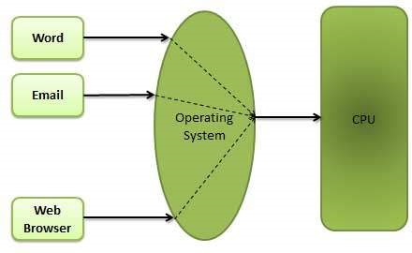
- A program that is loaded into memory and is executing is commonly referred to as a process.
- When a process executes, it typically executes for only a very short time before it either finishes or needs to perform I/O.
- Since interactive I/O typically runs at slower speeds, it may take a long time to complete. During this time, a CPU can be utilized by another process.
- The operating system allows the users to share the computer simultaneously. Since each action or command in a time-shared system tends to be short, only a little CPU time is needed for each user.
- As the system switches CPU rapidly from one user/program to the next, each user is given the impression that he/she has his/her own CPU, whereas actually one CPU is being shared among many users.
- Multitasking OS are of two types:
a) Pre-empetive multitasking
b) Co-operative multitasking
- In the pre-empetive multitasking, the OS allows CPU times slice to each program. After each time slice, CPU executes another task. Example: Windows XP
- In co-operative multitasking a task can control CPU as long as it requires .
- However, it will free CPU to execute another program if it doesn’t require CPU.
- A time sharing system allows many users to share the computer resources simultaneously. In other words, time sharing refers to the allocation of computer resources in time slots to several programs simultaneously. For example a mainframe computer that has many users logged on to it. Each user uses the resources of the mainframe -i.e. memory, CPU etc. The users feel that they are exclusive user of the CPU, even though this is not possible with one CPU i.e. shared among different users.
- The time sharing systems were developed to provide an interactive use of the computer system. A time shared system uses CPU scheduling and multiprogramming to provide each user with a small portion of a time-shared computer. It allows many users to share the computer resources simultaneously. As the system switches rapidly from one user to the other, a short time slot is given to each user for their executions.
- The time sharing system provides the direct access to a large number of users where CPU time is divided among all the users on scheduled basis. The OS allocates a set of time to each user. When this time is expired, it passes control to the next user on the system. The time allowed is extremely small and the users are given the impression that they each have their own CPU and they are the sole owner of the CPU. This short period of time during that a user gets attention of the CPU; is known as a time slice or a quantum. The concept of time sharing system is shown in figure.
- 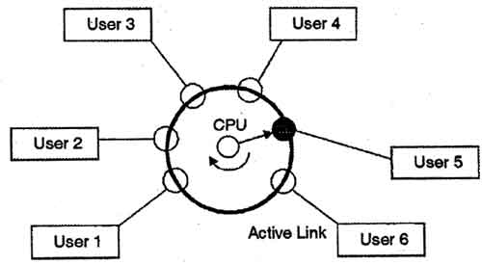
- In above figure the user 5 is active but user 1, user 2, user 3, and user 4 are in waiting state whereas user 6 is in ready status.

Multiprogramming
Sharing the processor, when two or more programs reside in memory at the same time, is referred as multiprogramming. Multiprogramming assumes a single shared processor. Multiprogramming increases CPU utilization by organizing jobs so that the CPU always has one to execute.
The following figure shows the memory layout for a multiprogramming system.
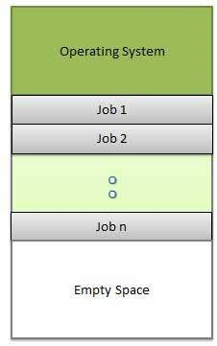
An OS does the following activities related to multiprogramming.
- The operating system keeps several jobs in memory at a time.
- This set of jobs is a subset of the jobs kept in the job pool.
- The operating system picks and begins to execute one of the jobs in the memory.
- Multiprogramming operating systems monitor the state of all active programs and system resources using memory management programs to ensures that the CPU is never idle, unless there are no jobs to process.
Advantages
- High and efficient CPU utilization.
- User feels that many programs are allotted CPU almost simultaneously.
Disadvantages
- CPU scheduling is required.
- To accommodate many jobs in memory, memory management is required.

3.Multiprocessing:
The os which uses two or more CPU in a single computer and running multiple programs concurrently is called multiprocessing. This is also called parallel processing. The multiprocessing system design is more complicated than single processor system because multiprocessing operating system must allocate resources to different processes running on different processor.
A multiprocessing OS can support the execution of multiple processes at the same time. It uses multiple number of CPU. It is expensive in cost however, the processing speed will be faster. It is complex in its execution. Operating system like Unix, 64 bit edition of windows, server edition of windows, etc. are multiprocessing.
e.g:UNIX.
3.Multi-threading: Multithreading is a recent development of multitasking, which enables the computer to execute more than one task in a single program.each distinct task is called a thread. For one thread handling printing task another handling storing data.
A program in execution is known as process. A process can be further divided into multiple sub-processes. These sub-processers are known as threads. A multi-threading OS can divide process into threads and execute those threads. This increases operating speed but also increases the complexity. For example: Unix, Server edition of Linux and windows.
4.Real-time OS:Real-time operating systems are on-line systems that respond to input immediately. This types of operating system are designed for the purpose of controlling and monitoring external activities with time constraints.
A real-time system is defined as a data processing system in which the time interval required to process and respond to inputs is so small that it controls the environment. The time taken by the system to respond to an input and display of required updated information is termed as the response time. So in this method, the response time is very less as compared to online processing.
Real-time systems are used when there are rigid time requirements on the operation of a processor or the flow of data and real-time systems can be used as a control device in a dedicated application. A real-time operating system must have well-defined, fixed time constraints, otherwise the system will fail. For example, Scientific experiments, medical imaging systems, industrial control systems, weapon systems, robots, air traffic control systems, etc.
There are two types of real-time operating systems.
Hard real-time systems
Hard real-time systems guarantee that critical tasks complete on time. In hard real-time systems, secondary storage is limited or missing and the data is stored in ROM. In these systems, virtual memory is almost never found.
Soft real-time systems
Soft real-time systems are less restrictive. A critical real-time task gets priority over other tasks and retains the priority until it completes. Soft real-time systems have limited utility than hard real-time systems. For example, multimedia, virtual reality, Advanced Scientific Projects like undersea exploration and planetary rovers, etc.They have well-defined time constraints, processing must be done within the defined time constraints otherwise the system will fail.e.g-p-855,BLMX are real-time operating system.

vi) Batch Processing:
A batch processing is a group of processing system in which all the required input of all the processing task is provided initially. The result of all the task is provided after the completion of all the processing. Its main functions are:
Batch processing is a technique in which an Operating System collects the programs and data together in a batch before processing starts. An operating system does the following activities related to batch processing −
- The OS defines a job which has predefined sequence of commands, programs and data as a single unit.
- The OS keeps a number a jobs in memory and executes them without any manual information.
- Jobs are processed in the order of submission, i.e., first come first served fashion.
- When a job completes its execution, its memory is released and the output for the job gets copied into an output spool for later printing or processing.
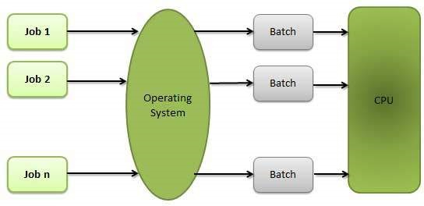
Advantages
- Batch processing takes much of the work of the operator to the computer.
- Increased performance as a new job get started as soon as the previous job is finished, without any manual intervention.
Disadvantages
- Difficult to debug program.
- A job could enter an infinite loop.
- Due to lack of protection scheme, one batch job can affect pending jobs.

Network operating System
A Network Operating System runs on a server and provides the server the capability to manage data, users, groups, security, applications, and other networking functions. The primary purpose of the network operating system is to allow shared file and printer access among multiple computers in a network, typically a local area network (LAN), a private network or to other networks.
Examples of network operating systems include Microsoft Windows Server 2003, Microsoft Windows Server 2008, UNIX, Linux, Mac OS X, Novell NetWare, and BSD.
The advantages of network operating systems are as follows −
• Centralized servers are highly stable.
• Security is server managed.
• Upgrades to new technologies and hardware can be easily integrated into the system.
• Remote access to servers is possible from different locations and types of systems.
The disadvantages of network operating systems are as follows −
• High cost of buying and running a server.
• Dependency on a central location for most operations.
• Regular maintenance and updates are required.

Some popular operating system:
Command line interface or command user interface(CUI)
a)MS-DOS(Microsoft disk operating system)-MS-DOS is a single user operating system for IBM(international Business machine) and IBM –compatible personal computer’s-DOS is a command line interface or command user interface(CUI) operating system. Which means that user gives the instruction to the computer by typing commands. To work in MS-DOS user needs to remember a lot of commands so,it is difficult to type long commands.
Graphical User Interface(GUI)
GUI - Short for Graphical User Interface, a GUI Operating System contains graphics and icons and is commonly navigated by using a computer mouse..
b)Microsoft windows(windows 95,windows 98):
Window 95/98 are GUI(graphical user interface) operating system.These tyes of operating system provides extra facility to use windows by providing menus Microsoft Windows 98 is the upgrade to Microsoft Windows 95. While this was not as big as release as Windows 95, Windows 98 has significant updates, fixes and support for new peripherals. Below is a list of some of its new features.
Protection - Windows 98 includes additional protection for important files on your computer such as backing up your registry automatically.
Improved support - Improved support for new devices such as AGP, DirectX, DVD, USB,
Interface - Users of Windows 95 and NT will enjoy the same easy interface..
Internet Explorer 4.0 - Included Internet Explorer 4.0
Customizable Taskbar - Windows adds many nice new features to the taskbar which 95 and NT do not have..
Active Desktop - Includes Active Desktop which allows for users to customize their desktop with the look of the Internet.The other features are as follows:
1.It is a GUI mode which is easier for a new user to learn and use the system.
2. Microsoft windows was designed to be not just an operating system but also a complete operating environment. That is all its program conform to standard way of working. This means that the experience gained by learning one windows program IS useful while using any other Microsoft windows program.
3.These types of operating system are single-user, multitasking operating system. That is user can run more than one programs at the same time. For example while editing a file,a sorting job can also be run on the background. the screen can be partitioned into multiple window and progress of different programs can be viewed on different windows.
With these features Microsoft windows became an operating system of choice for most personal computer users’ after1990.
Windows Me(windows Millenniums Edition):is upgrade of windows 98,release on sempt,14,2000.This system resources required for this operating system are significantly higher than previous version of windows.
Windows NT(NEW TECHNOLOGY): Windows NT 4.0 has the look and feel of Windows 95; however, it is a completely different Operating System. Windows NT contains advanced security features, advanced network support, advanced multitasking, user administration and much more. While NT is a very advanced operating system, even today, Windows NT is still used primarily by businesses
Windows NT has following features:
1.It is a GUI interface. the look and feel of Microsoft windows NT ,GUI is similar to that of Microsoft windows GUI.
2 It support multiprogramming and multiprocessing on system such that having multiple processors.
3 It has built –in networking and communication features so that Windows NT can be made to work as network client or server architecture.
4. It provides strict system security features.
5.It has a rich set of tools for software development and system administration.
The following features are not supported by NT4.
1internet connection sharing is not supported.
2.USB(universal serial bus )is not supported.
3. Automatic IP-addressing assignment is not supported.
Windows 2000 is an upgrade of windows NT.WINDOWS 2000 overcomes the drawbacks of windows NT4
The features of windows 2000 are as follows.
1 internet connection sharing is fully supported.
2. Automatic IP-addressing assignment is supported with no delay during startup
3. USB is fully supported ,and usable for networking.
4. plug and play is fully supported.

Windows XP is an upgrade of windows 2000.IT comes two versions-Home and professional. The professional version contains all the features of the home version plus more business features like networking and security features.
UNIX: It is a multi-user ,time –sharing operating system, which is widely used on a wide varieties of computers ranging from notebook to super computers.
LINUX: It is one of the open source operating system enhanced and backed by thousands of programmer’s world wide. It is a multi-tasking operating system, which is derived from inventor Linus Torvald.
Linux has following features.
a) Open source development model operating system.
b)Muli-user and Multitasking.
c) support wide varieties of network protocols.
d) cheaper to deploy.
e) More enhanced security features.
Selection of an operating system:
Operating system software is purchased with the computer system. since many operating system programs are made for a specific computer system they are often designed either by a hardware manufacture or jointly by a software and hardware companies.
Llinux and Windows operating systems are mostly used OS.

